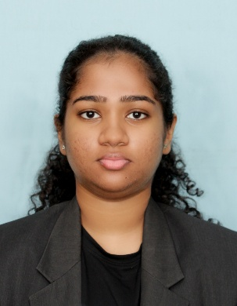
VOLUNTEER EXPERIENCE
OBJECTIVES

BSc (Hons) in Biotechnology Undergraduate

BUWANAJI DIAS NAGAHAWATTE

Head prefect of Sujatha Vidyalaya, Matara
Academic Year- 2023
Lead the student perfect guild more than 5000 students, coordinated school prefects blood donation (2023) and organized major school events.
Deputy Head Prefect,Primary School, Sujatha Vidyalaya,Matara(2015)
Member of the school Eastern Band
Swarnawarna Medalist (Environment Leader) Coordinated beach cleanup drives (2016-2019)
Director of Entertainment, Apex Institution Student Club (2026) - directed event planning and promotional strategy.
Active member of the Leo Club,Matara -Working on community service projects.

I am a biotechnology undergraduate student from SLIIT.I am passionate in life sciences and I would like to pursue a career in biotechnology product management and commercialisation. I am excited to improve the skills needed for cross-functional collaboration ,brand strategy, and market research to help successfully develop and launch biotech products to market.

PERSONAL DETAILS
 +94 702405040
 buwanajinagahawatte05@gmail.com
 361/1L, Kumarathunga Mawatha,Matara

AWARDS AND CERTIFICATIONS

- National –Level Orchestra Competition- 2nd place awarded “best shastriya” Title (2022)
- Provincial 2nd place (2017-2020, consecutive) Zonal 2nd Place (2021)
- Provincial 2nd place – National English Day Impromptu speech (2024) & Drama Competitions (2018)
- Provincial 2nd Place - National Level Music/Singing Competition (2018)
- Zonal 2nd Place - English Recitation (2018); Zonal 4th Place -Tamil Reading Competition (2017)
- Multiple Winning Event Awards-Inter-School Sport Meet
- CIMA---Certificate in Business Accounting (Fundamental level), currently studying exams not yet sat.

EDUCATIONAL QUALIFICATIONS

BSc (Hons) in Biotechnology –SLIIT, Sri Lanka Currently pursuing – Year 1, Semester 1
GCE Advanced Level (A/L) –Sujatha Vidyalaya, Matara. Bio Science stream (Biology, Chemistry, Physics) - passed 2024, 2025
GCE Ordinary Level (O/L) –Sujatha Vidyalaya, Matara.
Passed 9 A’s, English Medium – 2021

EXTRA CURRICULAR ACTIVITIES
LANGUAGE
English Announcer, Sujatha Vidyalaya, Matara
School Society- Media, stamp, dancing

Sinhala - Native
English - (Fluent - A pass at both OL-2021 and AL -2025)
Tamil (Basic)

TECHNICAL PROFICIENCY
Software: MS Word, MS Excel, MS PowerPoint, MS Access, Canva, Generative AI tools
Lab Skills: Basic laboratory techniques (titration, microscopy, sample preparation, lab safety protocols) & A/Level science practical

